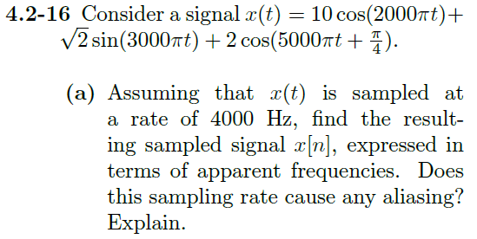

$$f_{1}=1000Hz, f_{2}=1500Hz, f_{3}=2500Hz$$

$$f_{a}={〈f_{0}+\frac{F_{s}}{2}〉}_{F_{s}}-\frac{F_{s}}{2}$$

$$f_{1 apparent}=3000 mod 4000-2000=1000Hz$$

$$f_{2 apparent}=3500 mod 4000-2000=1500Hz$$

$$f_{3 apparent}=4500 mod 4000-2000=-1500Hz$$

We can see that the apparent frequencies for f1 and f2 components are the same as their actual frequencies. But for f3 the apparent frequency is different than the actual frequency – because the sampling frequency is not meeting the Nyquist criteria of being twice the frequency of the largest frequency component of the signal.

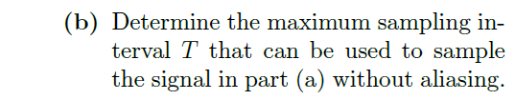

The maximum sampling interval T will be the inverse of the minimum sampling frequency. This minimum $F_{s}$ should follow Nyquist’s criteria of being at least twice the frequency of the largest frequency component. So, this is 5000Hz